Back to the Future: Warren v. Fitzgerald and Public Transportation in Baltimore
As we continue to make our way through a challenging and ever-evolving 21st century, we must begin to address a critical weakness plaguing our population: our consistent neglect of historic examples, passages, and precedent. In our search to find answers to today’s problems, we regularly overlook the lessons of history so readily available to us. Today’s technology and easy access to records and documentation leave us little excuse not to examine where we have come from in order to see where we are going. There is a reason why we regularly comment that things never change; we have an amazing capacity to overlooked lessons learned. Today, entire firms are dedicated to providing support and evaluation of past examples at exorbitant cost, as though it were something completely specialized and inaccessible to the average person. We all have the capacity to incorporate and learn from historic example, and now more than ever, it is critical that we do so.
In looking at Baltimore and the environment, historic legal cases provided a surprising amount of information relevant to today’s urban issues. Whether or not the people of these times considered the future consequences, we now have the advantage of being able to examine the cases in context and see how their actions and outcomes affected the city environment and policy. As we find ourselves addressing critical issues and the need to reshape our cityscapes for the future, these historic cases are now more relevant than ever. This particular snapshot in time, the case of Warren v. Fitzgerald, is more than a simple stockholder lawsuit attempting to halt trolley to bus conversion. The Warren’s case against transit firms in the post-WWII era highlights the negative impact on cities of a time fueled by the growth of the automobile industry. What does effective public transportation mean to the life of a city? As we learn, it is more than a means of movement; it builds community; business, and cohesiveness. While there are clearly other factors involved in maintaining an effective city, i.e., employment base, and good governance, public transportation provides the arteries along which everything else flows. It connects people who would otherwise be isolated in single vehicles, building a sense of community and purpose. As we address today’s environmental challenges, cities will play a tremendous role; they are the future of sustainable living. The history of public transportation in Baltimore, the case of Warren v. Fitzgerald, and the surrounding actions and events of the time, provide us with extremely relevant lessons learned about how we can rebuild and revitalize public transportation critical to the survival of our cities and environmental policy.
Baltimore Transit – A Brief History
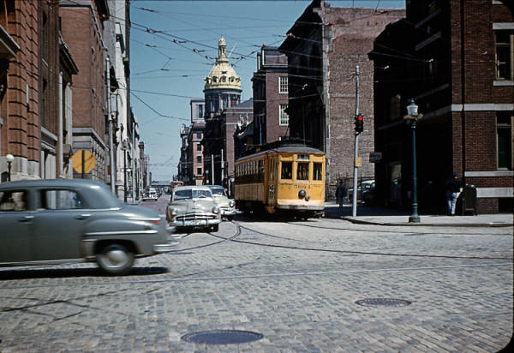
Maryland Digital Cultural Heritage 1952 Lombard St
Baltimore’s transit history begins somewhere around 1840 when urban stagecoaches, also known as Omnibuses, ran through the city connecting passengers from the railroad stations with hotels and businesses. By 1854, the idea of initiating horse car service along Baltimore Street had been presented before the City Council, at which point politics took over, and debates caused the actual construction of the line to be delayed for several years. Through the 1880’s, more lines were developed that reached further and further out from the center of town to such places as Pikesville, Woodlawn, and Towson. With the buildup of lines and infrastructure came the demand for more efficient means of powering the system. The first experiment with electric power came from Professor Leo Draft who in 1885 tested electric power on cars running on the Baltimore and Hampden lines. The steep and curving roads of the city proved to be particularly tricky, and full electric cable cars and trolleys did not debut in force until the early 1890’s. The last horse pulled car ran in 1902 on the Lorraine Cemetery line.
With the advent of electric power, the United Railways &Electric Company was formed and took control of transportation in Baltimore. In 1911, Baltimore’s streetcar system was one of the strongest in the country with a peak of 4,000 cars in its fleet. However, the late 1910’s and early 1920’s saw a major shift in forms of transportation with the introduction of the automobile. With post-WWI prosperity, more and more of the public was able to purchase their own vehicles, which in turn expanded suburb growth. A few buses began to appear in Baltimore on Charles Street in the 20s, but trolleys were still the prime form of public transportation.

Throughout the country, buses and rail transport were going head to head. The 1920’s saw a decline in passage and cargo traffic on steam railways as bus operations formed and took over. Studies of bus competition began to gauge the attitudes of the public and public officials. Cases in Ohio, Michigan, and Colorado examined questions of necessity, convenience, and the role of buses in the future. In Colorado in 1924, the local commission said, “It would be ill advised to say that motor-trucks have no place in this day and age. They already occupy a large and ever-increasing field, and one might just as well attempt to sweep back from the tides of the ocean with a broom as to prevent their operation within useful and proper lines; however, this does not mean that they may not, without proper control, become a menace to the very people they seek to serve...the railroads are absolutely necessary to our civilization”. As early as the 20’s people across the country knew there would be wide-reaching ramifications from the advent of motorbus transport; few predicted a near-complete conversion from rail.
Baltimore Transit Company Formed
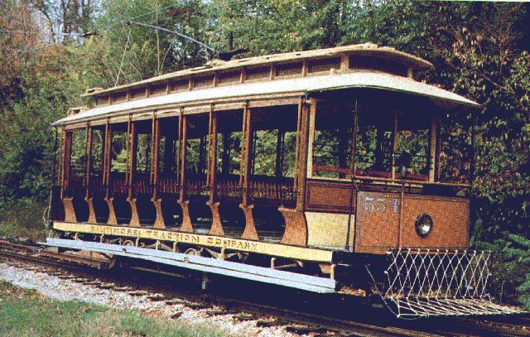
Baltimore Street Car Museum Collection
The United Railways & Electric Company continued to see declining revenues and equipment problems into the late 1920’s and 1930’s. Meanwhile, General Motors formed a front company in Chicago, National City Lines (NCL) in 1922. The Baltimore Transit Company (BTC) was formed in 1935, and NCL was reorganized into a holding company in 1936. In Baltimore, studies were conducted to try to evaluate the ailing transport system and the best vehicles to use on each line running in and around the city. Moreover, modernization and expansion were stressed in order to be able to remain competitive in the difficult environment. In 1940, the BTC spent $2 million on 108 streamlined trolley cars and 15 new buses. The trolley cars came out of Massachusetts and the buses were built by a General Motors subsidiary in Michigan giving Baltimore “one of the largest fleets of modern rail urban transit cars in the United States”. In 1941, BTC received its greatest surge and revitalization when the United States entered into WWII. Up to this point, BTC had stored rather than scrap unused streetcars in the midst of declining ridership. The BTC had learned from the United Railways & Electric Company’s failure to prepare for WWI. Rubber and gasoline were rationed during WWII, leading large numbers of the population to store or sell their private vehicles and again utilize public transportation. The profits made during the wartime shortages did not last however, and attitudes on public transit versus personal automobile use quickly changed in the years following WWII. During this period, National City Line out of Chicago purchased a major portion of BTC stock. The control of the BTC by out of town interests concerned with the auto, tire, and petroleum industries did not help matters at all either, as the comprehensive rail network was almost entirely dismantled in a mere ten years.
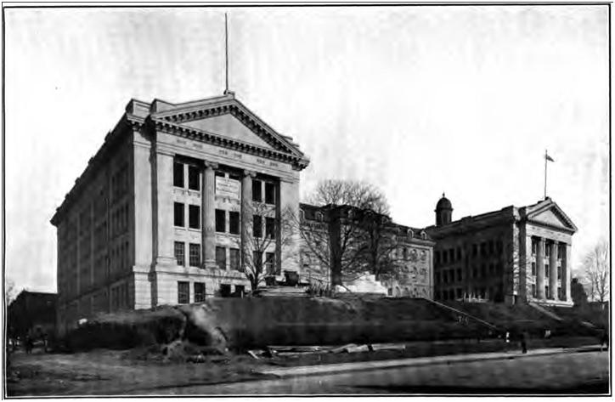
Wilson C. Warren
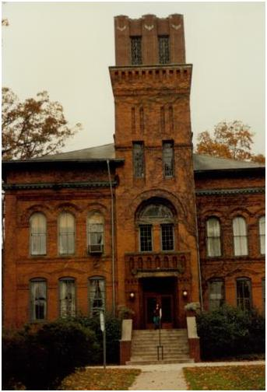
In 1915, Wilson Warren’s father, an engineer, purchased a home at 1903 Gwynn Oak Avenue in Baltimore County from where he operated a contracting business. In the same year, Warren, a product of the Baltimore public school system, graduated from Baltimore Polytechnic Institute under the leadership of Principal/Director Lieutenant William King. Baltimore Polytechnic Institute (BPI), founded in 1883, known most commonly as Poly, is a magnet high school in Baltimore, Maryland. Though established as an all male trade school, Poly now serves as a coeducational college preparatory institution that emphasizes mathematics, the sciences, and engineering . Warren later pursued a Bachelor of Science degree in civil engineering at the Tri-State College in Angola, Indiana. Tri-State was founded in 1884 and in 2008, it was renamed as Trine University to honor alumnus Ralph Trine.
Baltimore Polytechnic - 1911
Tri-state College
Baltimore Polytechnic - 1911
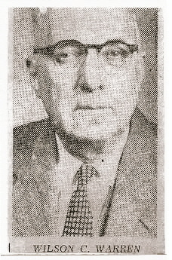
While at Tri-State during World War I, he was a member of the Student Army Training Corps but the armistice was signed before he saw active duty with the Army. After his marriage to Adelaide, Warren and his wife began acquiring BTC stock, and continued to do so for over 25 years. Warren was the individual owner of 1246 shares of common stock and 100 shares of preferred stock in Baltimore Transit Company. He and Adelaide were joint owners of an additional 29 shares of common stock. After the Warren v. Fitzgerald suit and subsequent appeal, Warren was primarily self-employed as a land surveyor. Throughout his life, he worked in a drug store, sold newspapers and was employed by the Pennsylvania Railroad. Mr. Warren said his job was his “main hobby” but that he enjoyed the pastime of beekeeping and had a number of hives on his place. In 1957, Warren ran as a candidate for first County Council under a new system of government that the people of Baltimore County adopted under a home rule charter for their political subdivision. Warren ran as an independent in the first district. During a forum held in Towson, Warren “hoped that if successful in the campaign, he would inspire others to help make the charter successful. He told of his career as an engineer, saying he had advanced through merit. He believed more engineers were needed in Legislature to apply their knowledge to public works.” At a Parkville forum where candidates were given three minutes for comments, Warren said, “he considered himself and ‘independent’ independent because he never had been in politics before. Years ago, he registered as a democrat – you had to register as one or the other and that was the thing to do in those days. At 59, he felt he had much experience to offer.” Despite his efforts, the Evening Sun ultimately endorsed a republican, John K. Davis, noting, “It would help to have a competent accountant on the Council”. Warren’s son, Charles W. Warren bought the house on Gwynn Oak Avenue in 1978 and continued a contracting business under Maryland Diving Service, which repaired bridges, pipelines, watercraft, and other underwater facilities. After the purchase, he took part in a special hearing to be allowed to continue to use this property this way and to store equipment. His elderly mother, Wilson Warren’s wife Adelaide, testified at the hearing. When Charles died on November 11, 2005 without a will, his wife, Darlene, daughter-in-law of Wilson Warren, held another special hearing to continue to use the property this way, and to take over the home. Maryland Diving Service is still listed online at 410-298-4471.
1957 Candidate Photo, Eve Sun
Time and Place
The Warren v. Fitzgerald case comes up at an interesting time in American cities. While today there are those who argue conspiracies by oil, rubber, and car companies, changed the face of public transportation, the whole story about the decline of mass transit in the U.S. is a story about the failure of public policy and about conflict among competing constituencies in the transportation policy process. While these companies could support their efforts through major funding and sole ownership of mechanisms, individual citizens also played a role in the mass transit to personal automobile shift. That being said, the concerned voices of the citizenry were often not loud enough to challenge wealthy interests and strong partnerships. The most obvious example outside of the Baltimore question was the road development in New York under the direction of Robert Moses. The battle of the East Tremont housewives against the Cross-Bronx expressway in the early 1950’s highlights how powerful connections in the political, business, and financial realm can be against thwarting the protests and actions of constituents. With the destruction of the East Tremont area of New York, came the loss of a vital urbanizing and assimilation area for generations of varied immigrants. Additionally, its integrated community supported its own local businesses. The highway, in essence, cut through the heart of the community, isolating neighbor from neighbor and citizens from park and business access. In the Baltimore example, the decline of mass transit plays a similar role in future of the city area. With a surge in interest in personal automobiles, their use seemed to be the future of transportation. As each individual purchased a vehicle, chain reactions of congestion, a shift to suburbs, and downtown business failure continued and grew. This resulted in transit companies across the country becoming increasingly unprofitable. GM and NCL were in the business of making money. Even though motor buses were uneconomical in the long run, in the short run, they were less expensive to purchase and operate than either electric trolleys or modern electric streetcars and in the struggling transit industry; the short run was all that mattered. By 1940, seventy-five U.S. companies were operating 680 diesel buses, primarily all made by General Motors. However, any argument of a conspiracy designed to destroy mass transit and stimulate the sale of automobiles can more accurately be characterized as a corporate strategy to sell diesel buses by creating first a pilot market and later a sole-source supplier relationship with effectively captive consumers. Regardless of the point of view, this all would have drastic consequences on the life and structure of American cities, especially in Baltimore. The Warren’s case, a question of stockholders rights in the age of monopolization, would bring to light the issues surrounding mass transit and effective cities.
The Case and the Appeal

“The question of whether the people of Baltimore are going to have buses or street cars is a question we are not raising here today. I said that before. The questions before the Court is whether the directors have acted in breach of their authority, have acted in bad faith, and have committed these other illegal acts which we have set forth.” – Herbert E. Witz, Solicitor for the Complainants
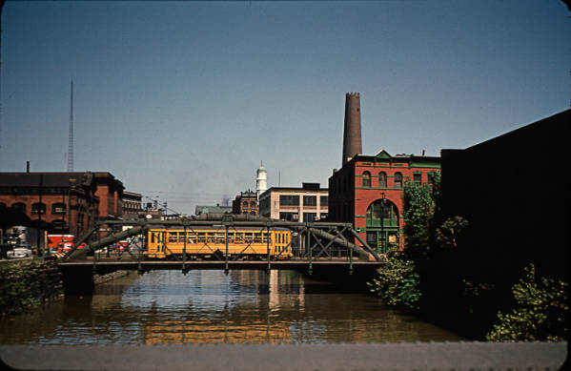
On June 12 1947, Attorney Herbert E. Witz, on behalf of his clients Wilson and Adelaide Warren, filed a suit against E. Roy Fitzgerald of National City Lines. The suit alleged that NCL, which owned a majority of BTC stock at the time, was working under a conspiracy to monopolize. At the time of the Warrens’ suit, NCL was under indictment in a similar case in California Federal Court. While Witz confirmed that BTC was indeed able and allowed to operate buses as a portion of their company, he alleged that NCL’s new controlling interests in the company intended to convert the entire system to buses through existing sole-source connections. Ultimately, Witz argued, this move was to benefit the strong controlling interests, and not the stockholders. This control and conversion by NCL made them more than simply a bus-operating portion of the BTC; Witz argued that this made them an illegal holding company whose moves should be approved by the stockholders. Additionally, the abandonment of the BTC assets and trolley infrastructure, he noted, amounted to a sale or transfer of a substantial part of the assets of BTC, and that could only have been done by a vote of stockholders. All told, nearly $21,000,000 in abandonment losses were to be sustained in the conversion. Witz questioned the good faith of Board of Directors of BTC as to whether or not stockholder should have been part of this decision. While the BTC said their top concern was the stockholders, they did not feel that stockholders should have been part of this decision.
Maryland Digital Cultural Heritage Jones Falls 1952
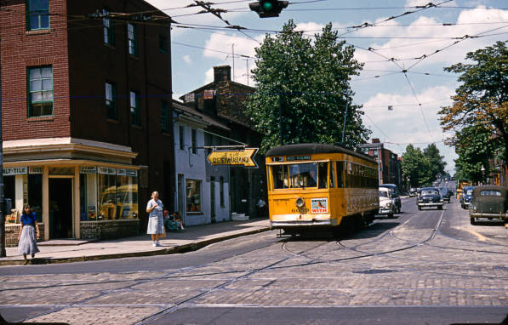
The city immediately asked to enter the case. Baltimore had completed numerous contracts with BTC as part of the bus and one-way street conversion plan. Calling the BTC a utility, the mayor said that it “is not operated merely for the benefit of the stockholders, but the general public also has rights”. The city and the company had built up a tax and street maintenance pact that was riding on the conversion process. Witz went on in the trial to show how buses had been ordered and built prior to BTC ever receiving authority from the Baltimore Public Service Commission (PSC). The BTC director argued that it was good business to take these steps in anticipation of future projects. Simon Sobeloff, representing the city after their intervention said, “This is not a mere family quarrel between a stockholder and his company. We have intervened because we conceive this to be a controversy in which the city is going to be seriously affected by any action your Honor takes…the public has an interest here because it has entered into a contract with this company”. The Warrens were stockholders for over 25 years and received regular stock reports. A certain percentage of bus conversion was indeed taking place. This particular and most recent conversion, however, was done in a negotiation between the PCS and the BTC outside of court and stock reports. City council worked with the BTC and presented the conversion plan to the PCS, which approved it in October of 1946. Sobeloff argued that the public and the stockholders had every chance to come forward prior to June 1947, but that they had remained silent, with the exception of this “complaining stockholder”. Sobeloff went on to say that NCL had no real influence in the other cities where it operated and that other cities were converting without problems or complaints. He said, “It is a more economical operation…from a public standpoint, you get improved traffic conditions by bus operation”. Ironically, urban mayors in the 1960s would later appeal to the federal government for urban responses to their cities chocked by traffic congestion and losing their economic competitiveness to the every-growing suburbs.
Maryland Digital Cultural Heritage Wolfe & Eastern 1952
Despite Sobeloff’s insistence that the Board of BTC acted in good faith, researched the situation fully, and were completely aware of the entire process, Director Joseph P. Healy had different answers for Witz on the stand. He would not admit to any knowledge of GM ownership of NCL and that while stockholders were his top concern, he did not feel they should be involved. He also admitted that, despite the agreements and plans in place with the city, there was no accounting plan for making up the losses in the abandonment process. Healy also argued that competitions for products, i.e. tires, etc., were open and fair, but contract reviews would later prove otherwise. Healy also said that he had never heard of the complaints being brought against NCL in California or elsewhere. He went on to insist that any question of fraud, bad faith, or his knowledge of such things questioned his character. He said, “I would like the privilege to defend my intelligence and honor”, but several of his ‘speeches’ upholding the quality of the character of the NCL representatives were cut off by the judge.

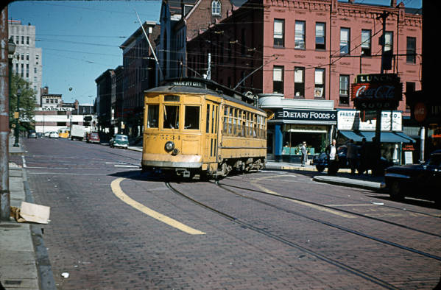
The connections and contracts in the case were clear. Buses were making inroads and interests across the board were being served but the Warrens’ case and subsequent appeal were eventually dismissed. The judge ultimately argued that, “Whether the property is in fact obsolete, and whether the conversion is wise, are business questions which are not reviewable by the court”. In a July Sun article, Judge John Tucker said, “Circumstances were sufficiently suspicious to indicate an effort on the part of the companies to make purchases into the users of their particular products to gain either absolute or partial control of the corporation using their products to a great extent. But, I don’t say it’s illegal”. NCL would later be convicted by a jury of 12 housewives in Federal District Court in Chicago of conspiracy under anti-trust laws. The government charged that in exchange for cash advances, NCL was giving exclusive contracts to companies like GM and Standard Oil. E. Roy Fitzgerald was fined $1. He was quoted as saying: The policy of National City Lines has been to acquire and modernize urban transport systems through the extensive use of buses. It plans to continue this policy”. It was not until 7 years later in 56, that the company was required to take competitive bids. Meanwhile, the BTC in Baltimore moved full steam ahead with the conversion process. Evidence would later reveal that the motor bus was becoming the least popular and the least profitable transit vehicle, but at the time, it was the least expensive to purchase and to operate. The bus eventually became the only transport capable of responding to demands for service on lightly traveled routes and far reaching suburban areas. Remedies for the problems facing mass transit would not be available until much later. The most important consequence was not the displacement of streetcar systems [but rather] the dominance of a single manufacturer in the diesel bus market and the preemption of routes and markets that might have been more economically served by the electric trolleybus. Additionally, one cannot rely on the supplier alone; consumers also need to make the right decisions in supporting new public policy.
Maryland Digital Cultural Heritage Saratoga rush hour car 1952

Public Reaction at the Time of the Case

With each last trolley route ride, “mourners” would gather for the last journey. In June of 1947, streetcars 1, 17, and 29 took their final trips. Most of the riders opposed the conversion, which that day substituted, buses for the trolleys. On the same day of this particular “death watch”, the Better Baltimore Commission was overseeing a ceremonial parade of buses on St. Paul and Calvert Streets. In the six months following the dismissal of the Warren v. Fitzgerald case, the BTC received over 1500 complaints from groups and individuals. Bus complaints included failure to stop, overcrowding, bus stop locations in front of businesses, and long waits. Operators of both trolleys and buses received complaints. Richard F. Ruzicks, president of the North Harford Improvement Association had this to say about transit service at the time: “Something is radically wrong with the transit system”. He filed a formal complaint with the BTC.
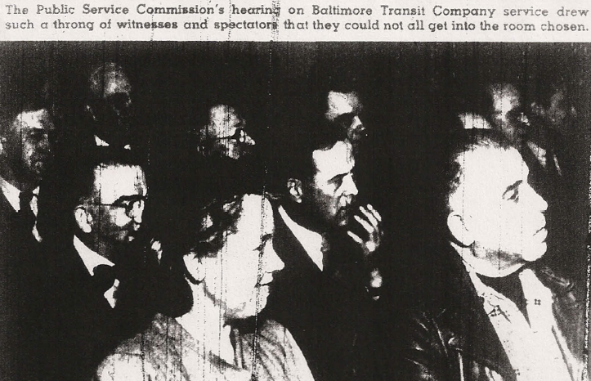
After the Warrens’ suit, the BTC was to immediately use 132 buses and replace 70 miles of trolley track. A Sun editorial noted, “However quickly the conversion takes place, it
Baltimore Sun Magazine February 8 1948
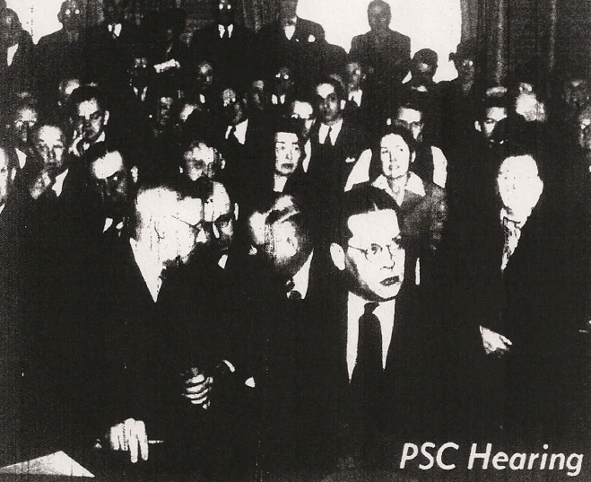
will not be too soon to give the city partial relief from its traffic snarls”. Despite this predicted relief, traffic worsened and citizen complaints continued to rise. PSC hearings and inquiries began and polls showed that a large number of people preferred trolley cars to buses by a margin of 3 to 1. In February of 1948, a Public Service Commission hearing on the BTC drew a large crowd. In the audience were numerous members of neighborhood improvement associations. The hearing, held in the Munsey Building, could not accommodate all who wanted to attend, and many had to listen from the hall. Later that month, groups began to protest one-way streets and bus conversion. Miss Aimee Weber, president of the National Housewives, pointed out “it takes seven buses to carry the passengers that four streetcars can carry.” She also opposed “one way streets with their extra noise in quiet residential sections”. Edgar L. Heaver, representing the Roland Park Civic League, said, “the people are disgusted by buses and request the return of the green streetcars…the buses are horrible, stinking sardine cans with all the characteristics of a bucking bronco…the bus windows are smeared by oil and that the air is brought into the windows laden with oil”. Mr. Heaver went on to cite the ever increasing cost of oil and predicted that if “the company persists in substituting buses for streetcars, it will be in receivership within 5 years”. While his prediction did not manifest itself in the half-decade he estimated, it is certainly an issue for auto and bus transport today. The Baltimore Sun was also accused of playing a negative role in the process. T. Ken Mersereau of the Hillen Road Improvement Association said the Sunpapers “are playing a more harmful role than useful and are playing politics for their own circulation…do the owners of the Sunpapers own stock in the Baltimore Transit Company”? Incredibly, Mersereau also proposed a subway system for the city, which was not built until 35 years later in 1983. Members of city council and citizens went on to support trackless trolleys over buses, basically electric buses minus the track system. By March 5, 1948 a measure in a bill before City Council provided that the BTC completely cease fixed rail operations and opt for
Baltimore Sun Magazine February 8 1948
trackless trolleys. But support suddenly shifted, and ultimately those against the trackless trolleys said that the city needed to uphold it bus contracts and agreements with BTC/NCL. Union representatives of motor bus companies also insisted that trackless trolleys would mean harm to its employees both financially and health wise: most had already been trained for buses instead of trackless trolleys and trackless trolleys posed an electrocution hazard. He said, “Any change in the conversion plan will nullify many provisions of the agreement and may result in industrial strife. The trackless trolley bill was defeated. Ralph E. Grodrian, acting general manager of the BTC, said in regards to buses and the complaints, “Engineers throughout the country are seeking constantly to improve bus fuel and engines so as to eliminate much of the smoke and odor about which citizen complain”. Public polls continued to show unfavorable feelings about the system, and bus issues are still a concern today.

Impacts

Trolley hearings continued for the next several years along with bus conversion. As trolley lines shifted to buses, confusion ensued. Routes changed constantly and stops were shifted. In May of 1948, the BTC distributed 100,000 leaflets showing the changes. Many persons onboard the buses were ‘sightseers’ just “riding along to see where the buses go”. BTC continued to make shifts and changes not in line with original plans. Councilman Bonnet said, “He and his colleagues went along with the legislation necessary for the companies conversion from streetcar to bus operations because they expected the company to cooperate with the councilmen from the various districts…the company has gone against the wishes of the people of East Baltimore and against the requests of the councilmen”. Councilman Jarosinski said, “We can’t go along with the Baltimore Transit Company if they will not go along with our people”. Despite these sentiments, BTC continued its conversion and line movement. One way street protests and route change questions were largely dismissed. Streets and pavement began to crack under the weight of heavier buses and the Bureau of Highways in Baltimore tried to come up with solutions to the “fuel drippings, splattered from the exhausts of buses when they halt for passengers”. Old track sites began to accumulate trash and other debris. In order to allow for buses to pull closer to curbs (trolleys stopped in the middle of the road) numerous trees were removed from city streets. With buses needing to pull curb side, arguments began over parked cars vs. spaces for buses to pick up and discharge passengers. All of this of course meant, “buses moving out from the curb must enter a stream of traffic which has attained fairly high speed”. This ultimately caused more delays and congestion in the city then the buses were supposed to fix. The last trolley in Baltimore ran on Saturday February 27, 1954.
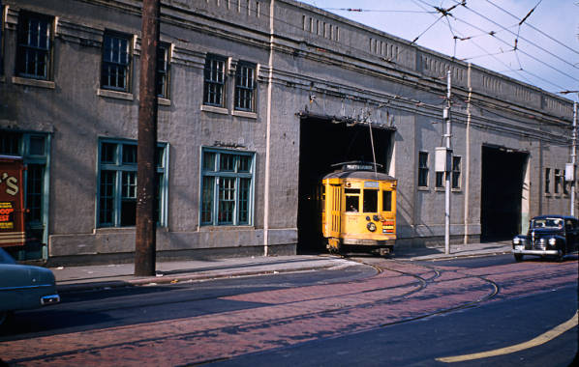
Maryland Digital Cultural Heritage Car House at Lombard and Haven 1952

The National City Line Legacy

The Baltimore Commission began studying transit problems in the city in 1951 and in 1956 noted: We believe the Baltimore Transit Company would be in a healthier state if National City Lines Would pick up its marbles and go home. The control seems to have shaken the confidence of the community in the Baltimore utility and has been a disturbing factor in public relations”. There were strikes in 1951 and 52, and at one point, the city went 40 days without public transportation. Union leaders were requesting a local run authority and the removal of NCL in Baltimore. A grand inquest took place and found that NCL in 1954 was only investing $574,436 in Baltimore compared with $2.4 million in 1945. No substantial additions to the system were made between 1949 and 1955, ridership was down 50%, employees had been cut 37%, and fares were doubled and redouble. NCL held onto a profit/value of $3.8 million, leading the head of the inquest to note that the transit knowledge and experience of NCL has been well rewarded”.
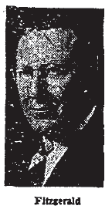
Later, when NCL went after the Washington D.C. transit system, CTC, a congressional review of their operations ultimately led to a sudden firestorm of competing bids for the system. As with Baltimore, NCL proposed the same plan for Washington: quick conversion to an all bus fleet. The head of the transit union that argued before Congress said, “NCL’s refusal to arbitrate collective bargaining strikes had forced strikes in communities where NCL operated”. A commissioner in Washington said, “the conditions of the National City-CTC agreement were unacceptable…the sales terms included congressional approval of the house-passed restoration bill, which included tax concessions; exemption form an obligation to removed street card tracks and repave the streets during a planned conversion to all all-bus system”.
Washington Post & Times Herald June 16, 1957

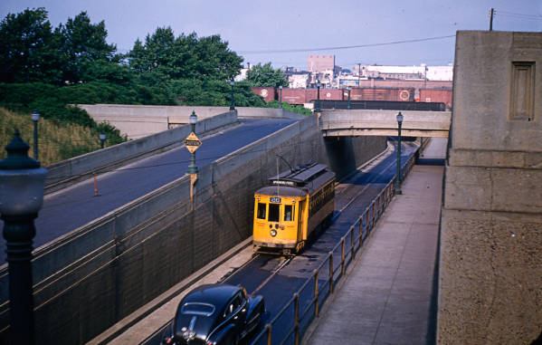
Lessons Learned and Baltimore and the Environment
Maryland Digital Cultural Heritage Penn RR Underpass 1952
An examination of Warren v. Fitzgerald case and surrounding events of the time provides a surprising amount of information relating to Baltimore’s public policy and the changing nature of the urban environment. One stockholder's attempts to prove bad faith and fraudulent conversion contracts opened up a Pandora’s box of secret negotiations and even the unsolved murder of a BTC head in 1948. Influences of the time including oil companies, tire companies, and all others associated with the development of the automobile and bus. The post WWII age brought on the age of the automobile and with that, entire highways and suburbs designed around the car. Whatever schemes were alleged by the Warrens and the anti-bus public at the time, the citizenry also made their choice by choosing the independence of personal vehicle ownership. Despite the allure of this new technology and other “waves of the future”, the arguments for gas-fueled transport led to more problems than they solved: more congestion, pollution, and a breakdown of city communities. The results in hindsight show a clear connection between efficient public transportation and effective, vibrant cities and communities. This snapshot of Baltimore history provides us with rich lessons learned on how we can positively change our transit, cities, and policy for a successful and sustainable future.

Bibliography
The Sun Articles
- “Trolleys Faster in Year 1912.” The Sun 12 January 1947: 30-4
- “Suit Opposes B.T.C. Bus Plan: Two Stockholders Call It An Illegal Scheme.” The Sun 17 June 1947: 15-3
- “New One-Way Street, Bus Changes Go In Effect Today: Mourners Take Final Car Rides.” The Sun 22 June 1947: 32-3
- “City To Enter Transit Case: Ordered By Mayor to Fight Suit To Halt Conversion.” The Sun 27 June 1947: 17-2
- “Anti-Bus Case to Be Studied: City AND B.T.C. Ask Dismissal Of Injunction Suit.” The Sun 28 June 1947: 15-6
- “Bad Faith Denied at Hearing Seeking to Block B.T.C. Buses.” The Sun 8 July 1947: 8-3
- “Bus Contracts to Be Scanned: Plaintiffs In Suit Against B.T.C. Win Court Permission.” The Sun 9 July 1947: 9-4
- “Bus Conversion Suit is Dismissed.” The Sun 11 July 1947” 6-3
- “Legal Problems Tackled by B.T.C.: Possible Appeal in Injunction Suit Anticipated.” The Sun 19 July 1947: 18-2
- “2 Transit Stockholders Appeal Bus Suit Ruling.” The Sun 7 August 1947: 7-1
- “Car To Bus Shift Approved By City.” The Sun 2 December 1947: 8-4
- “B.T.C. Plans in High Court: Arguments Heard For And Against Changes to Buses.” The Sun 11 December 1947: 13-1
- “1,500 Criticize Operation of Transit Lines: Most Of Grievances Are About Bus Service, Report Shows.” The Sun 15 December 1947” 28-8
- “Editorial: A Futuristic Angle To The Transit Problem.” The Sun 2 January 1948: 8-2
- “Editorial: Now The B.T.C. Is Free To Improve Its Service.” The Sun 15 January 1948: 12-3
- “B.T.C. Buses Called Small, Smelly, Noisy: Crowd Overflows PSC Offices As Transit Inquiry Begins.” The Sun 21 January 1948: 28-1
- “Muth Wars Of Transit Chaos Here: Tells PSC That Court Must Oust Present B.T.C. Management.” The Sun 22 January 1948: 30-5
- “Public Frenzy Remark Laid to PSC Head: Civic Group Leader Makes Charge: Bosley Says, ‘I Don’t Recall’.” The Sun 23 January 1948: 28-1
- “B.T.C. Improvement Put Up To Utility: PSC General Council Says ‘It Is Your Business’.” The Sun 28 January 1948: 26-2
- “Bus Decision View Differ: Final PSC Hearing Marked By Conflicting Testimony.” The Sun 29 January 1948: 30-6
- “Such Is Life: PSC Hearing.” The Sun 8 February 1948: Sunday Magazine
- “Bill To Repeal 1-Way Street Setup Doomed: Unfavorable Report id Voted After Groups Protest Buses.” The Sun 28 February 1948: 20-1
- “Editorial: The New Traffic Issue – Buses Or Trackless Trolleys.” The Sun 3 March 1948: 12-1
- “Transit Firm Hearing Ends: Bid For Note-Issuing Right Is Under Advisement By PSC.” The Sun 5 March 1948: 5-4
- “Death Seen For Trackless Trolley Bill: Abramson Predicts Death Of Move To Block Conversion To Buses.” The Sun 6 March 1948: 20-5
- “Perkins Replies to Muth Telegram: Reminds Councilman of Availability to PSC.” The Sun 7 March 1948: 20-2
- “Cartoon: Evolution of Transportation.” The Sun 17 March 1948: 28-4
- “Transit Group Denies Charge: National City Lines Please Innocent of Violation.” The Sun 6 April 1948: 6-3
- “Baltimore St. Buses Urged: Transit Official Tells PSC They Will Ease Traffic.” The Sun 9 April 1948: 4-3
- “Transit Company Asks Hearing On Bus Law.” The Sun 16 April 1948: 12-3
- “Baltimore St To Be Rid Of Trolley Cars: B.T.C. Also Authorized To Reroute Eight Lines Under Conversion Plan.” The Sun 22 April 1948: 40-1
- “Driving-Test Plans Ready: Transit Company to Unveil, Demonstrate Machine Today.” The Sun 27 April 1948: 8-1
- “2 Trolley Lines Shifted To Buses: Baltimore Street Clear of Fixed-Wheel Traffic.” The Sun 10 May 1948: 28-4
- “Editorial: One Undeniable Gain From Buses On Baltimore Street.” The Sun 11 May 1948: 14-1
- “Passage of Bill To Permit All-Night Parking Seen Sure: 3 To Oppose B.T.C. Bills.” The Sun 21 May 1948: 36-6
- “Wires, Tracks Being Removed: Abandoned Rails Contain Over 11,500 Tons Of Steel.” The Sun 23 May 1948: 26-2
- “Transit Plans to Be Studies: Thursday Set for Hearing By Public Service Unit.” The Sun 1 June 1948: 9-3
- “B.T.C. To Convert Two More Lines: Authorized To Run Buses Over 5-33 And 32 Routes.” The Sun 16 June 1948: 34-7
- “One-Way Plan For 2 Streets Still Blocked: Three Obstacles Are In Way Of Cathedral And Charles Projects.” The Sun 2 July 1948: 32-8
- “Editorial: Something Else To Worry About.” The Sun 9 July 1948: 12-2
- “Many Comparisons Made, But the B.T.C. Still Stands Pat.” The Sun 24 June 1948: 4-2
- “Paving Cracks At Bus Stops: Officials Study Problem Of Conversion Program.” The Sun 2 August 1948: 7-3
- “Baltimore Transit’s Annual Report Wins High Award.” The Sun 7 August 1948: 12 August 1948: 32-1
- “Shuttle Service Hearing on Thursday.” The Sun 13 August 1948: 10-1
- “Track Sites to Be Cleaned: City To Remove Trash At Old Transit Rights Of Way 8 September 1948: 8-4
- “Transit Service Progress Cited: Company Tells PSC Improvements Are Being Made.” The Sun 5 October 1948: 34-6
- “Explain Plan On Bus Stops: Atkinson Urges Ordinances Permitting Changes.” The Sun 18 November 1948: 12-1
Wilson C. Warren Articles
- “Editorial: County Council.” The Sun 2 January 1957
- “Editorial: County Council.” The Sun 14 January 1957
- “Editorial: County Election.” The Sun 15 January 1957
- “20 Country Rivals Talk: Parkville Forum Gives Council Candidates 3 Minutes.” The Sun 15 January 1957
- “Candidate for Baltimore County Council, 1st District.” The Evening Sun 16 January 1957
- “County Council Candidates Talk. “ The Sun 17 January 1957
Chicago Daily Tribune Articles
- “Baltimore Traction Lines Buy 27 Cars with Rubber Springs.” Chicago Daily Tribune Feb 4, 1936;
- “National City Trust Case Goes to Jury.” Chicago Daily Tribune March 12, 1949; pg A5
- “Jury Deliberating Bus Monopoly Case in Second Day.” Chicago Daily Tribune March 13, 1949; pg A7
- “National City Lines and 13 Others Fined in Anti-Trust Case.” Chicago Daily Tribune April 2, 1940; pg A5
The Washington Post
- “Baltimore Transit to Spend $2,000,000 on New Equipment.” The Washington Post July 3, 1940; pg. 21
- “Firm Runs 103 Lines on Wolfson-Like Code.” The Washington Post and Times Herald Jun 16, 1956
- “Dying CTC Franchise Now Coveted by Four Rival Groups.” The Washington Post and Times Herald Jun 25, 1956
- “National City Lines Founder” The Washington Post and Times Herald; Jun 16, 1957; pg. A16

Article, Websites/links, and Case Documents
- Baltimore Polytechnic Institute. <http://www.bpi.edu/apps/directory/directory_list.jsp?start=90&directoryLName=&rn=8746&directoryGraduationYear=1915&directoryFLName=&class=dark+darkBorderTop&padding=3&directoryFName=&sortCriteria=directoryLName&rn=6622>.
- Baltimore Street Car Museum. <http://www.baltimorestreetcar.org/>.
- bojee7. You Tube: The Death of the Streetcar. <http://www.youtube.com/watch?v=hN1vi-SwUXo&feature=related>.
- Bus3204. You Tube: Baltimore Streetcar Museum Cars. <http://www.youtube.com/watch?v=1wEq0vFfxlo>.
- CharlesStTrolley. You Tube: Charles St. Trolley - Historic Vehicle. <http://www.youtube.com/watch?v=0JB0HEhD_Es&feature=related>.
- CharlesStTrolley. You Tube: Charles St. Trolley - Modern Vehicle. <http://www.youtube.com/watch?v=d0i8bibLZv8&feature=related>.
- ETC. Trolley vs. Diesel Q & A. <http://www.trolleycoalition.org/qanda.html>.
- Heritage, Maryland Digital Cultural. Baltimore Transit Co. and Potomac Edison Slides - Baltimore Streetcar Museum. <http://collections.mdch.org/cdm4/browse.php?CISOROOT=%2Fbtpe>.
- Infrastructurist, The. Chart: America's Streetcar Renaissance. <http://www.infrastructurist.com/2009/05/04/chart-americas-streetcar-renaissance/>.
- MDLandRec.Net. <http://www.mdlandrec.net/msa/stagser/s1700/s1741/cfm/index.cfm>.
- Papenfuse, Edward. Research, Editing, and Courses. <http://mdhistory.net/>.
- Sadecki, 2/15/2009 G.T. Johnston Ed.: M. Historical Society of Baltimore County - 350th Chronology - Draft. 15 2 2009. <http://www.hsobc.org/Documents/BC%20Timeline.pdf>.
- Wikipedia. Maryland Transit Administration. <http://en.wikipedia.org/wiki/Maryland_Transit_Administration>.
- Wikipedia. Simon Sobeloff. <http://en.wikipedia.org/wiki/Simon_Sobeloff>.
- Warren v. Fitzgerald, 189 Md. 476, 56 A.2d 827 (1948)
- BALTIMORE CITY CIRCUIT COURT (Equity Docket A, Miscellaneous) Warren v. Fitzgerald, et al., 1947, 87A, pp. 306, 336, no. A29809 ½ [MSA T55-94, 1/20/11/49]
- BALTIMORE CITY CIRCUIT COURT (Equity Papers A, Miscellaneous) Warren v. Fitzgerald, et al., 1947, box no. 1625, no. A29809 ½ [MSA T53-5214, 3/9/13/7]
- COURT OF APPEALS (Records and Briefs) Warren v. Fitzgerald, et al., 1947, October Term, no. 108 [MSA S1733-1226, 1/27/3/23]
- COURT OF APPEALS (Opinions) Warren v. Fitzgerald, et al., 1947, October Term, no. 108, MDHR 11, 488-7 [MSA S393-261, 1/66/6/12]
- COURT OF APPEALS (Miscellaneous Papers) Warren v. Fitzgerald, et al., 1947, October Term, no. 108, MDHR 10, 205-2 [MSA S397-117, 1/65/8/11]
- COURT OF APPEALS (Transcript) Warren v. Fitzgerald, 1947, October Term, no. 108, vol. 1-2, MDHR 9974-15 [MSA S434-75, 1/67/10/28]
PUBLIC SERVICE COMMISSION (Docket) In the Matter of the Baltimore Transit Company's petition for approval to convert certain of its rail lines to free wheel operation and to reroute certain of its rail lines, vol. 11, case no. 4789 [MSA T366-11, OR/23/8/100]

Paul
Slater
Washington Post July 3, 1940
Paul
Baltimore Polytechnic Institute
Evening Sun Jan 16, 1957
Evening Sun Jan 16, 1957
Sun Jan 17, 1957
Sun Jan 15, 1957
Sun, Jan 15, 1958
Bianco
Bianco
Bianco
Case transcripts pg
Sun, June 27, 1947
Case transcripts pg 81
Case transcripts pg 82
Case transcripts pg 85
Lexis case summary
Sun, July 9, 1947
The Washington Post and Times Herald, June 16, 1955
Bianco
Sun, June 22, 1947
Sun, December 15, 1947
Sun, January 15, 1948
Sun, February 28, 1948
Sun, February 28, 1948
Sun, February 28, 1948
Sun, February 28, 1948
Sun, March 6, 1948
Sun, May 10, 1948
Sun, May 21, 1948
Sun, May 21, 1948
Sun, August 2, 1948
Sun, November 22, 1948
Washington Post and Times Herald, June 16, 1956
Washington Post and Times Herald, June 16, 1956
Washington Post and Times Herald, June 25, 1956
Washington Post and Times Herald, June 16, 1956

